Reading and Book Circulation, 1600-1800
Libraries, Lives and Legacies Festival of Research
University of Stirling
17-18 April, 2023

https://borrowing.stir.ac.uk/

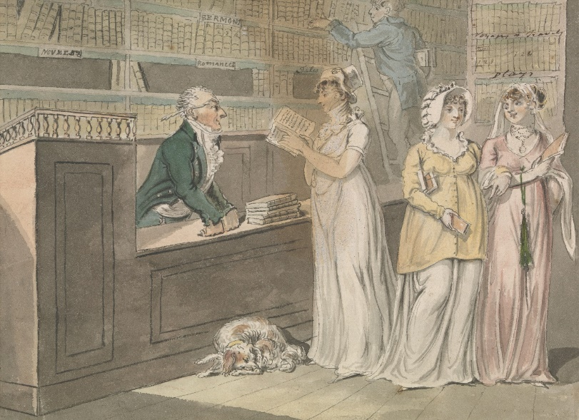
Isaac Cruikshank, The Lending Library (between 1800 and 1811), by kind permission of the Yale Centre for British Art https://collections.britishart.yale.edu/catalog/tms:8602
Programme
Day 1
Time | Place | Event | Place | Event
Monday 17 April
9:00 | Foyer, Iris Murdoch Building | Registration
9:30 | Main Lecture Theatre | Welcome: Nina Parish, Head of Division of Literature and Languages, University of Stirling  Introduction to the ‘Books and Borrowing 1750-1830 project’ and Demonstration of our Digital Resource:  Katie Halsey, Matthew Sangster, Kit Baston, Maxine Branagh-Miscampbell
10:30 | Foyer | Tea
11:00 | Room 1 | Panel 1a: Reading Practices in Non-Institutional Spaces  Chair: Abigail Williams  Tim Pye, Had; Lent; Returned: Borrowing from the Country House Library  Abigail Williams, ‘I myself chose Bruton Saturdays’: Mapping Non Elite Book Use in Rural Settings  Melanie Bigold, Establishing Book Legacies: Collecting and Bequeathing ‘Her Books’  Sam Bailey, The Circulation and Reading of Erotic Books in Coffee-House Libraries | Maitland Room | Panel 1b: Institutional Libraries  Chair: Josh Smith  Kit Baston, The Advocates Library and the Writing of History  Zachary Brookman, Building the Bürgerbibliothek: Donating to the Zurich Public Library in the Seventeenth and Eighteenth Centuries  Gerard Lee McKeever, French Historians and Narratives of Literary History  Maximiliaan van Woudenberg, English Texts at Home and Abroad: Book Circulation and Reading Habits in Research, Subscription, and College Libraries
13:00 | Foyer | Lunch
13:45-14:30 | Stirling University Archives | Kelsey Jackson Williams, Hands-On Session with Books from the Leighton Library with exhibition by Jacqueline Kennard
14:30 | Room 1 | Panel 2a: Circulation  Chair: Matthew Sangster  Angela Esterhammer, Reading Piecemeal: John Galt’s Miscellaneous Publishing Ventures  Cleo O’Callaghan Yeoman, ‘Still my ardent sensibility led me back to novels’: Metaphors of Reading, 1760-1820  Amy Solomons, ‘Counted over my books and found I had about 800 here already’ (1830): Anne Lister’s Reading Spaces and Experiences  Charley Matthews, Reading and Reviews as Sites of Gendered Power for David ‘Doddy’ Lyndsay (1790-1830) and Anne Lister (1791-1840) | Maitland Room | Panel 2b: Private and Religious Libraries  Chair: Kit Baston  Michelle Craig, Discovering Dr William Hunter’s Use of Books: Antiquarianism and Reading within the Hunterian Library  Natasha Simonova, ‘The very land of parchments & papers’: The Wrest Park Library as Coterie Hub  Joshua Smith, ‘The best theological library that I know in Scotland’: The Borrowings and Borrowers of the Leighton Library, Dunblane  Baiyu Andrew Song, ‘I have a much larger room to sleep in, and good closets for my books’: Joseph Kinghorn (1766-1832) and His Library
16:30 | Foyer | Tea
1700 | Main Lecture Theatre | Keynote 1  Chair: Katie Halsey  Deidre Lynch, The Social Lives of Scraps: Shearing, Sharing, Scavenging, Gleaning
18:00 |  | Short break
18:15 | Foyer | Gin Tasting Reception, sponsored by Alexander House Rentals https://www.alexanderhousescotland.com/
19:30 | Stirling Court Hotel | Dinner

Day 2
Time | Place | Event | Place | Event
Tuesday 18 April
9:00 | Main Lecture Theatre | Plenary Roundtable: Borrowers’ Registers Across Scotland  Chair: Jill Dye  Lara Haggerty, The Library of Innerpeffray  Robert Betteridge, National Library of Scotland  Elizabeth Quarmby-Lawrence, Edinburgh University Library  Robert MacLean, Glasgow University Library  Rachel Hart, University of St Andrews Library
10:30 | Foyer | Tea
11:00 | Room 1 | Panel 3a: Readers, Libraries and Loss  Chair: Andrew Pettegree  Jessica G. Purdy, Libraries of Lost Books?  Jacob Baxter, Sir William Temple and His Readers  Elise Watson, Addressing the ‘Black Holes’ of Ephemeral Catholic Print | Maitland Room | Panel 3b: Books on the Move  Chair: Maxine Branagh-Miscampbell  Jill Dye, Missing, and wishing, and hoping?: Sources for Identifying Printed Books held by the Society of Antiquaries of Scotland 1780-1830  John Stone, Diasporic Books and Recusant Institutions: Remaking the Libraries of Anglophone Catholic Colleges in Spain, 1770-1820  Kelsey Jackson Williams, Looting or Preservation?: Monastic Libraries and English Collectors During the Napoleonic Wars  Brittani Ivan, On the Margins of the Public: Women in the Australian Subscription Library (1826-1869)
12:30 | Foyer | Lunch
13:30 | Room 1 | Panel 4a: Annotation, Transcription and Reading  Chair: Gerard Lee McKeever  Ruth Abbott, Thomas Gray and the Art of Transcribing Historical Manuscripts  Robert Betteridge, Lord Hailes’s Reading of David Hume’s Four Dissertations  Natalie Tal Harries, Unveiling ‘the treasures that would charm a bibliomaniac’: Walter Scott’s Supernatural Scholarship and Romantic Reading Communities  Hannah Jeans, Unprofitable Romances?: Reading, Identity and Seventeenth-Century Women’s Networks | Maitland Room | Panel 4b: Education  Chair: Cleo O’Callaghan Yeoman  Maxine Branagh-Miscampbell, Tobias Smollett, Fool of Quality and The Art of Drawing: The Grindlay Bequest and Childhood Reading Practices at the Royal High School, Edinburgh  Mary Fairclough, Lyric, Hymn and School Text: Barbauld’s ‘An Address to the Deity’ and Reading Aloud  Duncan Frost, Bird Books: Advertising, Consumption and Readers of Songbird Training Manuals  Robin Rider, Assessing the Eighteenth-Century Market for Algebra
15:30 | Foyer | Tea
16:00 | Main Lecture Theatre | Keynote Lecture 2  Chair: Matthew Sangster  Andrew Pettegree, The Universal Short Title Catalogue: Big Data and its Perils
17:00 | Main Lecture Theatre | Closing Remarks
17:15 |  | Close

Day 3
Wednesday 19th April: Conference Excursion

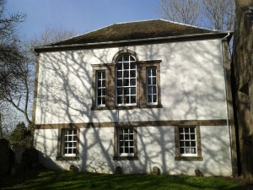

09:30: Meet at front of Stirling Court Hotel for trip to Innerpeffray Library
10:30: Tour of Innerpeffray Library
13:00: Return to Stirling Train Station

Thanks to our funders:
Division of Literature and Languages, University of Stirling
Faculty of Arts and Humanities, University of Stirling
University of Liverpool
Alexander House Rentals (alexanderhousescotland.com)
Library and Information History Group, Chartered Institute of Library and Information Professionals

Thanks to our helpers:
Jacqueline Kennard
Julia Caparros Vega
Olympia Nicolaide
Rachael Tarrant
Laura Paterson
Sara Hotchkiss
Gema Silva Ferrandez
Emily Rae
The Books and Borrowing Team

